Based on aggregated data from both experiments, the five AI models (ChatGPT, Claud AI, DeepSeek, Grok AI, Microsoft Copilot) are evaluated across Coverage, Clarity, Traceability, Completeness, and Redundancy. Scores are averaged from both experiments (scale: 0–100).

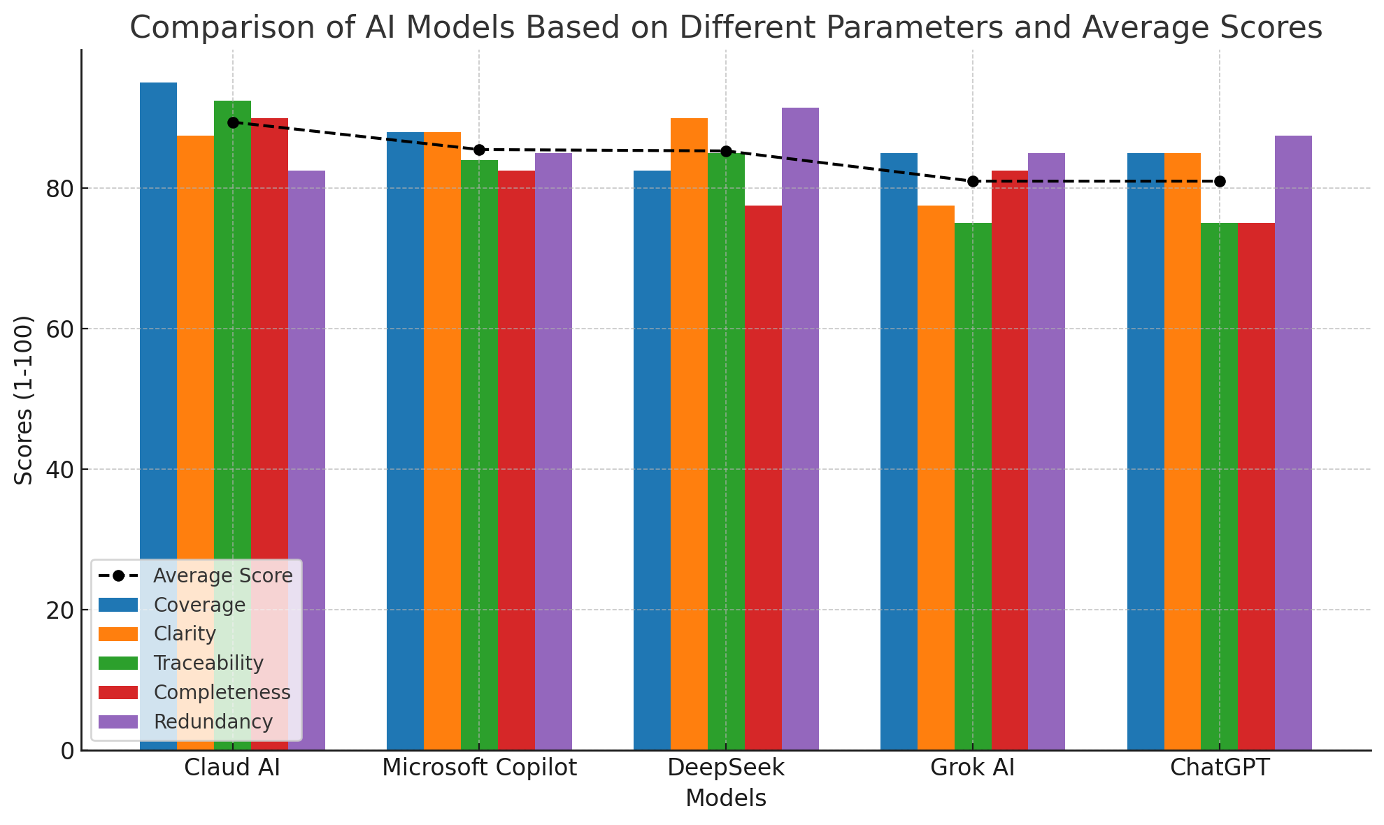

Aggregated Scores
Model | Coverage | Clarity | Traceability | Completeness | Redundancy | Avg.
Claud AI | 95 | 87.5 | 92.5 | 90 | 82.5 | 89.4
Microsoft Copilot | 88 | 88 | 84 | 82.5 | 85 | 85.5
DeepSeek | 82.5 | 90 | 85 | 77.5 | 91.5 | 85.3
Grok AI | 85 | 77.5 | 75 | 82.5 | 85 | 81.0
ChatGPT | 85 | 85 | 75 | 75 | 87.5 | 81.0
Note: Redundancy scored inversely (higher = less redundancy).

Parameter-Wise Analysis
1. Coverage (Extent of captured requirements)
- Claud AI (95): Captured granular details (e.g., lab workflows, staff lifecycle management).
- DeepSeek (82.5): Lost points for over-consolidation (e.g., merged discharge/follow-up).
- Grok AI (85): Missed nuances (e.g., ER tracking logic).
- Recommendation: Use Claud AI for exhaustive requirement mapping.
2. Clarity (Precision & readability)
- DeepSeek (90): Concise, action-oriented language (e.g., "generate unique patient ID").
- Claud AI (87.5): Slightly verbose but well-structured.
- Grok AI (77.5): Vague descriptions (e.g., "reasonable time frame").
- Recommendation: DeepSeek or Copilot for streamlined clarity.
3. Traceability (Linkage to source)
- Claud AI (92.5): Explicit section mapping (e.g., "Appointment Booking Section").
- Copilot (84): Clear labels (e.g., "Emergency Care Section").
- Grok AI (75): Weak references (e.g., "PAGE 1 - Doctor Features").
- Recommendation: Claud AI for compliance-critical projects.
4. Completeness (Critical details included)
- Claud AI (90): Addressed ambiguities (e.g., ER prioritization, inventory thresholds).
- ChatGPT (75): Omitted specifics (e.g., undefined "industry standards").
- DeepSeek (77.5): Missed ER logic and backup procedures.
- Recommendation: Claud AI for high-stakes implementations.
5. Redundancy (Duplicate requirements)
- DeepSeek (91.5): Minimal duplication (consolidated related features).
- Claud AI (82.5): Minor overlaps (e.g., lab requests vs. results).
- Grok AI (85): Moderate repetition (e.g., billing/payment).
- Recommendation: DeepSeek for concise documentation.

Key Insights
- Claud AI Dominates:
  - Highest coverage, traceability, and completeness.
  - Ideal for complex, regulated environments (e.g., healthcare).
  - Weakness: Slightly verbose (affects clarity).
- DeepSeek vs. Copilot:
  - DeepSeek: Best clarity + low redundancy, but sacrifices coverage.
  - Copilot: Balanced all parameters; excels in usability-focused projects.
- Avoid for Critical Projects:
  - Grok AI: Poor traceability and clarity.
  - ChatGPT: Low completeness (misses technical specifics).

